**LetsUpgrade Assignment Lab-1**

1. Screenshot of Launch Status.

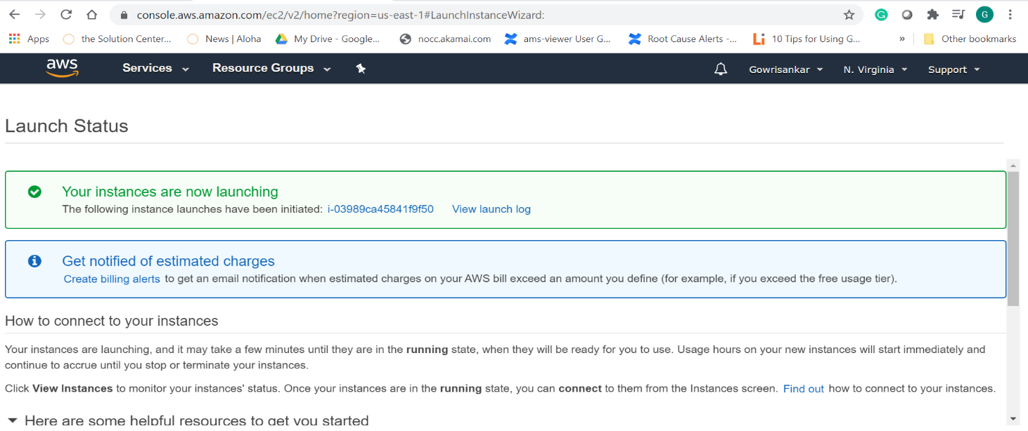

1. 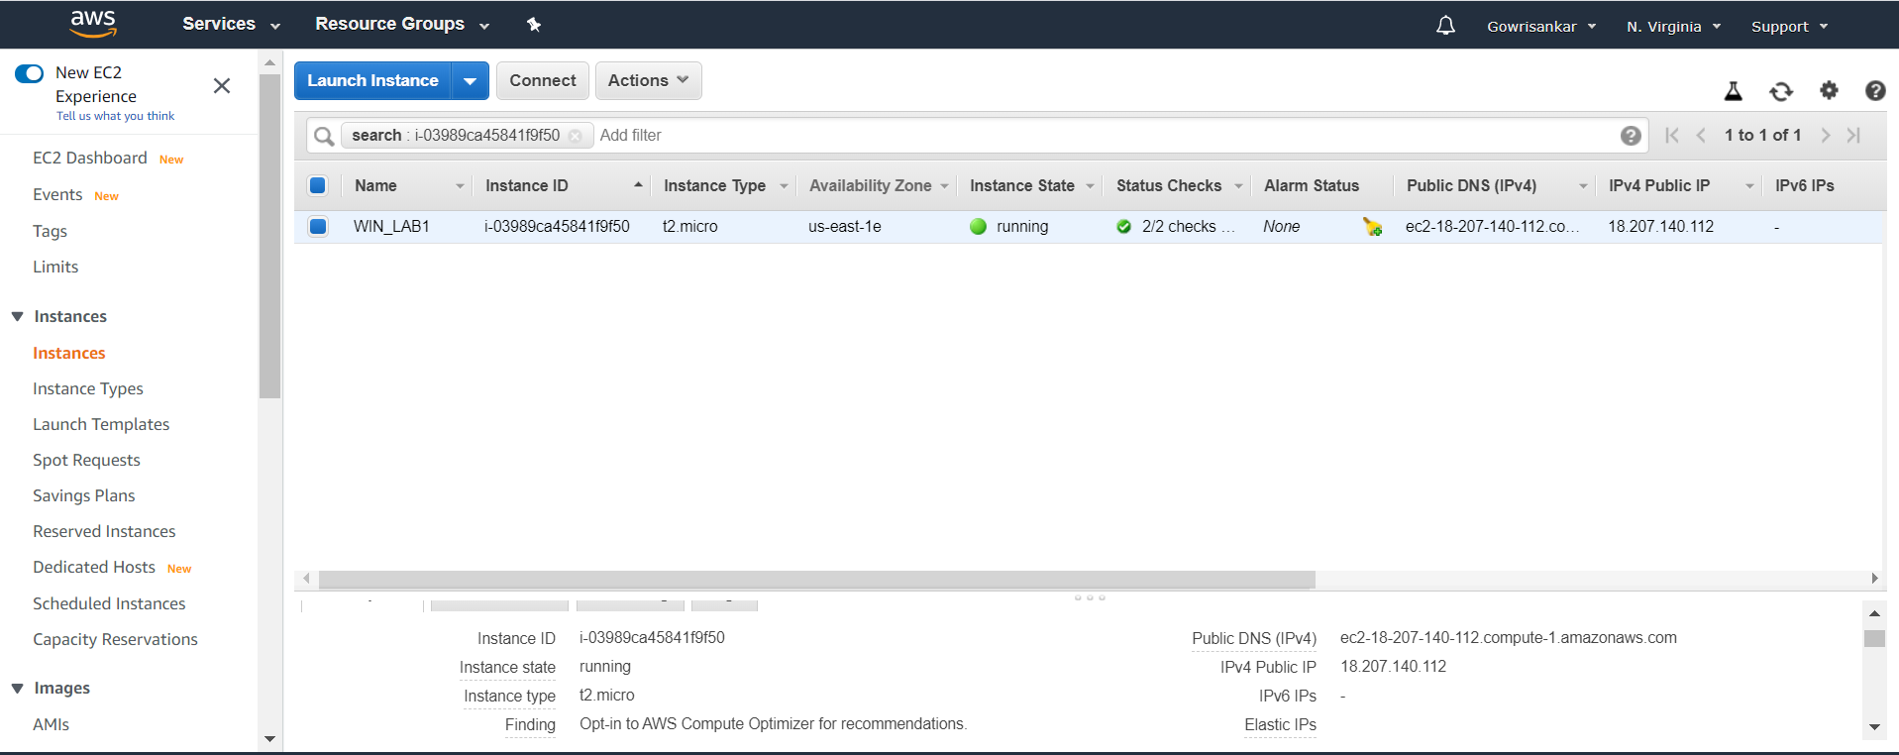Screenshot for dashboard for windows launched instance id and associated machine IP Address. (NOTE: Instance id:- i-03989ca45841f9f50 and IP Address:- 18.207.140.112)
2. 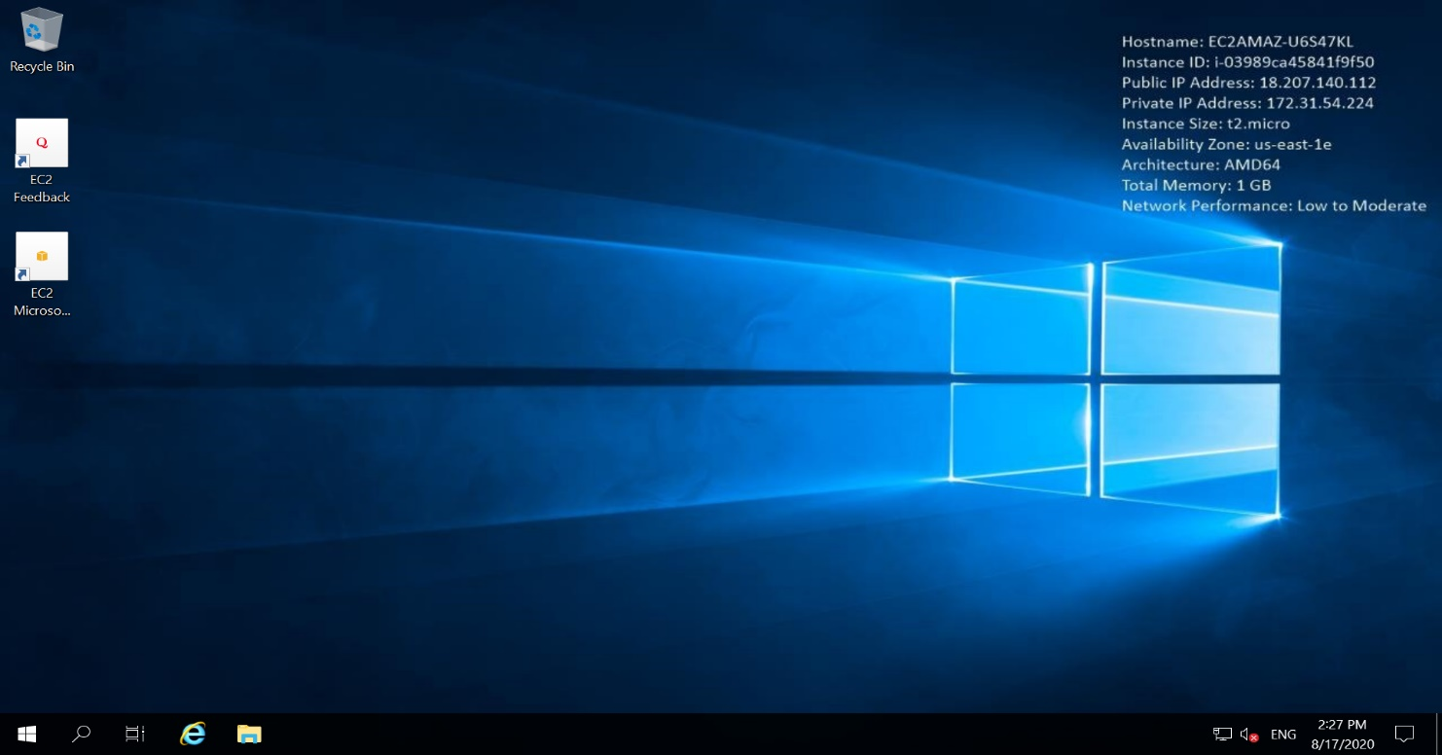Connected to my windows instance via RDP.
3. Successfully installation of IIS Web Server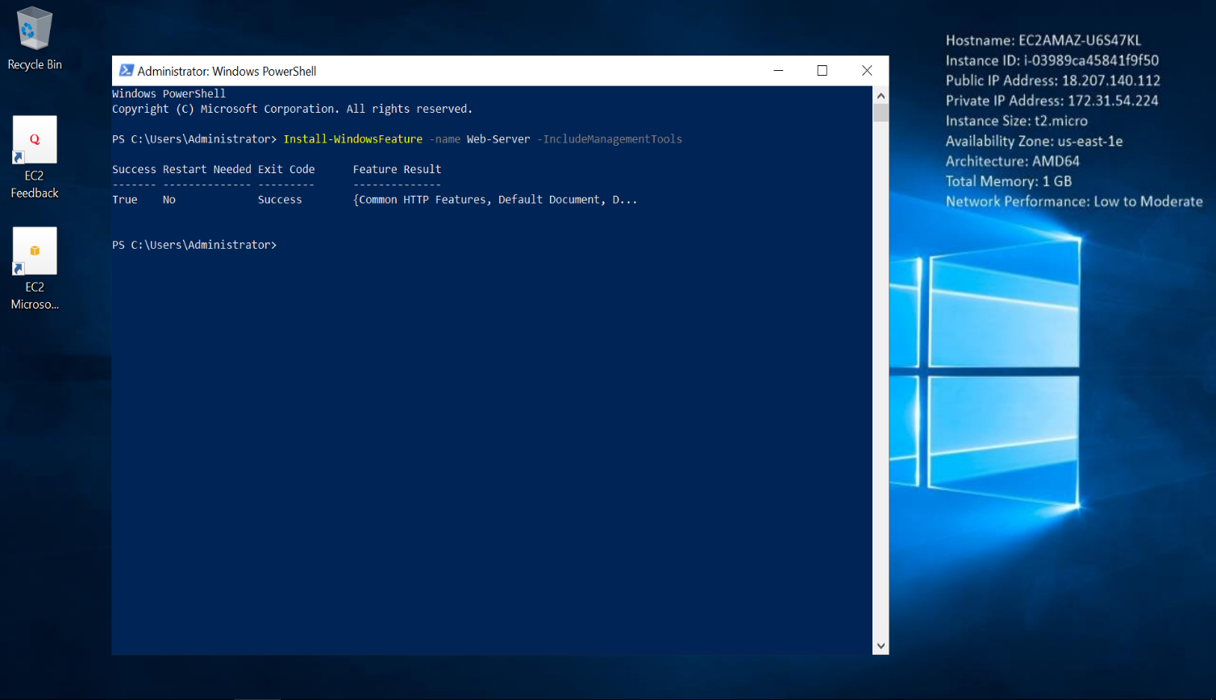.
4. 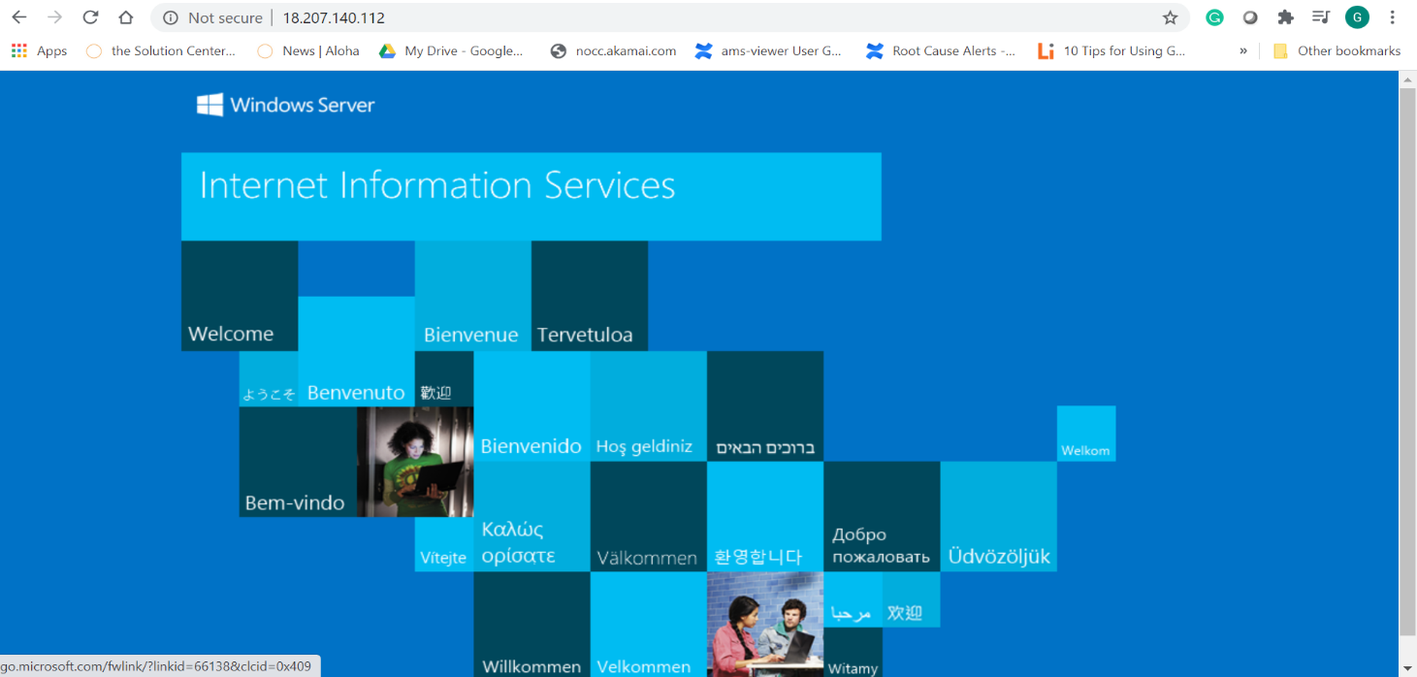Done able to see webpage in browser.

**LetsUpgrade Assignment Lab-2**

1. Launch status for ubuntu instance.

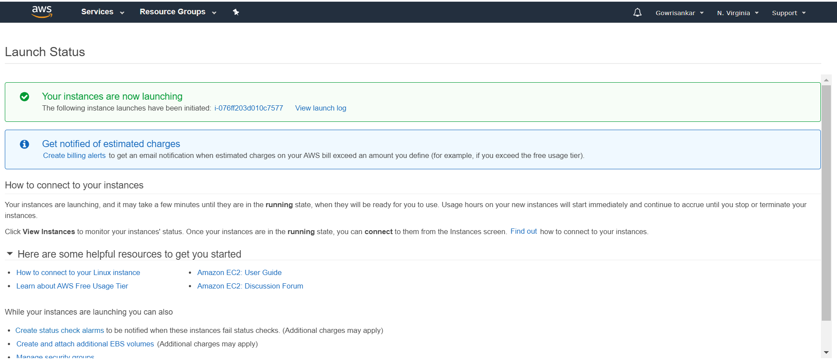

1. Screenshot for dashboard for ubuntu launched instance id and associated machine IP Address. (NOTE: Instance id:- i-076ff203d010c7577 and IP Address:- 52.91.121.7)

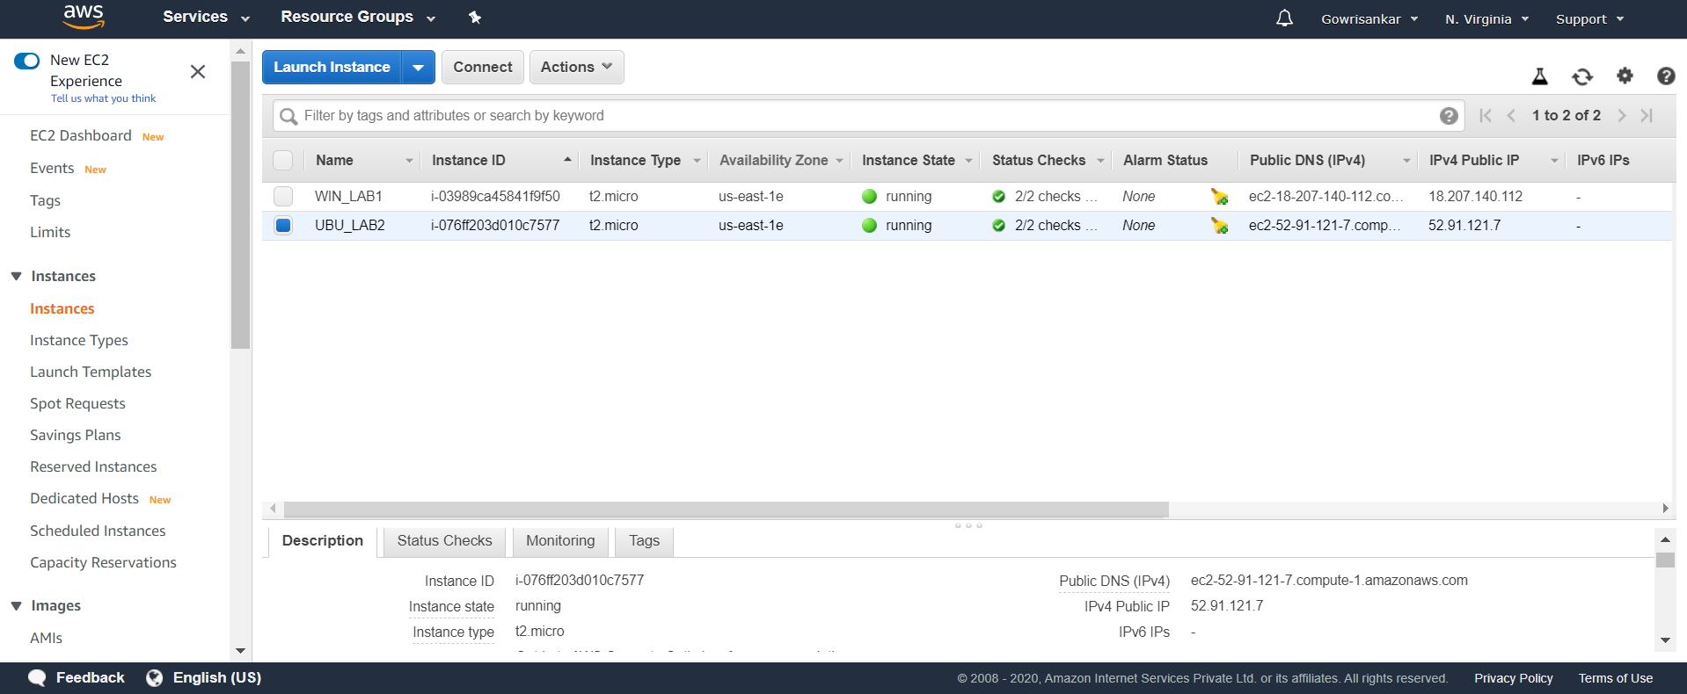

1. Launched ubuntu instance via Mobaxterm

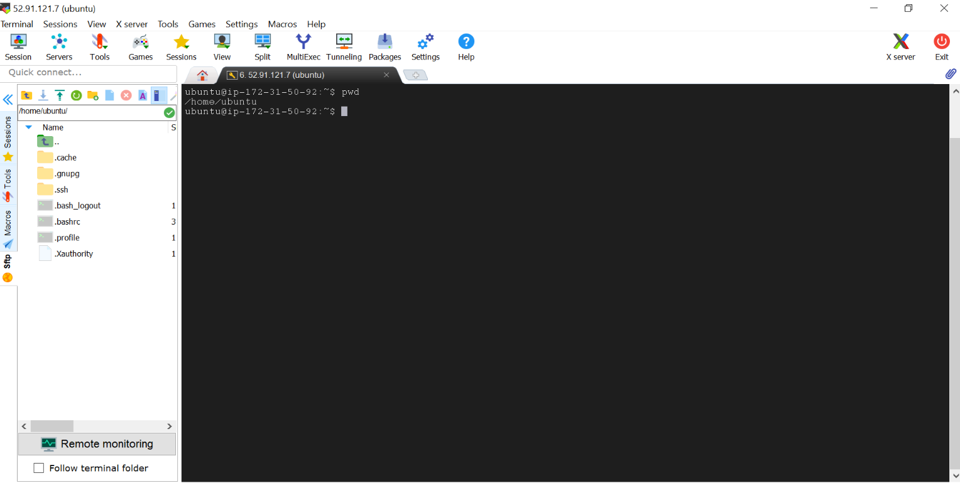

1. 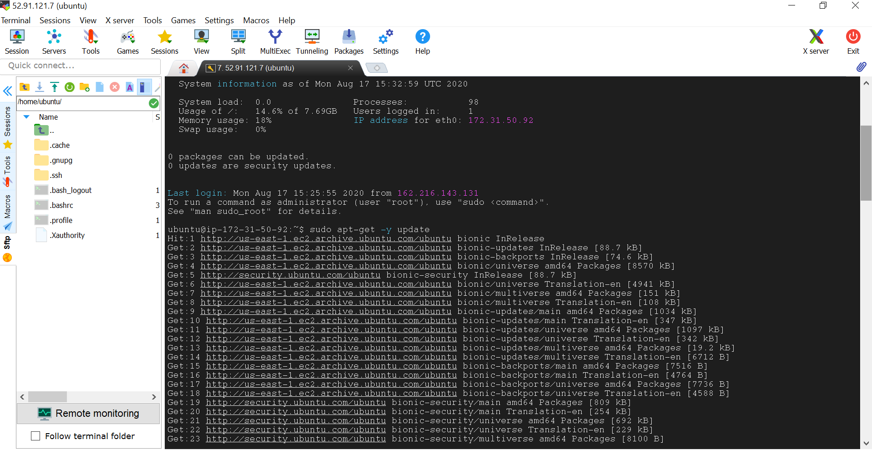Installed Ngnix webserver in ubuntu.

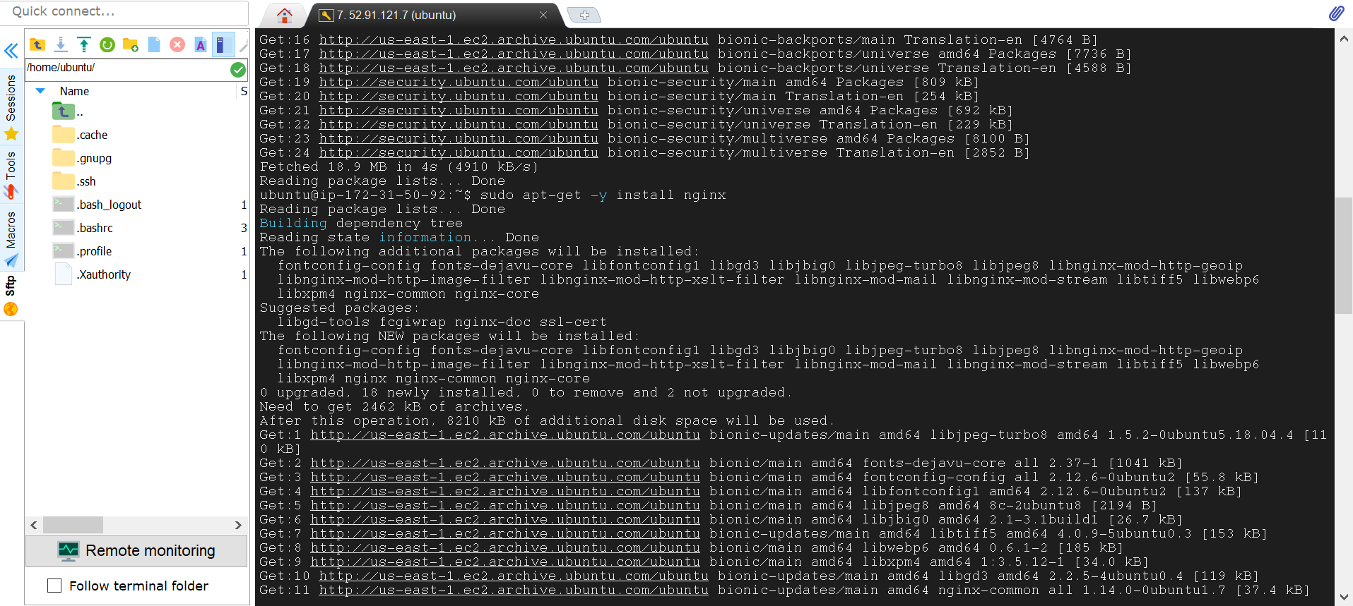

1. successfully installation of ngnix.

